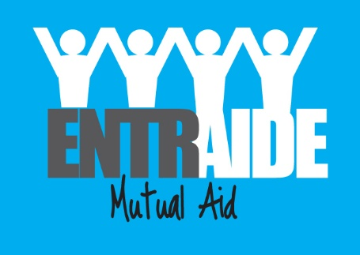
Application for Employment
About the Vacancy

Vacancy applied for: Volunteer Coordinator
Employers Name: ENTRAIDE (MUTUAL AID) | Closing Date: noon Friday 19th July 2017 at 12:00
Return the completed form preferably by email to: info@entraideuk.org.uk  Or by post to: ENTRAIDE (Mutual Aid)  Chelmsley Wood Baptist Church Centre  Hedingham Grove  Birmingham B37 7TP | How did you Hear about the vacancy:
Personal Details
Name(Last, First, Middle) | Daytime phone Number:
Address | Evening Phone Number:
Postcode | Email Address
Are you legally entitled to work in the UK?

We will ask for proof if you are successful in this application

National Insurance Number:
Do you hold a valid Driving Licence?

If you require any particular arrangements when attending an interview, please give details below:
Employment History (Start with your most recent job)
Name of Employer | Dates  (To – From) | Position held | Reason for Leaving
Education and Training (Start with most recent)

University, College, School or other place of Education | Dates | Course Studied and Qualification achieved
Any other evidence to support your application including how you meet the person specification?

( Use additional sheet if necessary)

References

Reference 1 | Reference 2
Name:  Organisation name:  Occupation:  Contact Number:  Email:  Relationship to you: | Name:  Organisation name:  Occupation:  Contact Number:  Email:  Relationship to you:

Can we contact your references before interview? YES □ NO □

I can confirm that, to the best of my knowledge, the information I have given on this form is correct.

/ /

Signature Date

Monitoring form
ENTRAIDE is striving to treat everyone equally whatever their race, sex, age or marital status and whether they are disabled or lesbian or gay.

As part of our monitoring process, we ask you to complete the questions on this sheet. This information is confidential and it will be used only to monitor recruitment and to ensure that it is done fairly. This form will not be seen by the Selection Panel who interviews you. It is not compulsory to fill in this form; however we hope that you will.

1. My sex is: FEMALE MALE

2. How would you describe your race?

A White British Irish
Any other white background, please write in

_______________________________________________________

B Mixed White and Black Caribbean
White and Black African White and Asian
Any other Mixed background, please write in

_______________________________________________________

C Asian or Asian British Indian Pakistani Bangladeshi Any other Asian Background, please write in
______________________________________________________

D Black or Black British Caribbean African Any Other Black background, please write in

______________________________________________________

E Chinese or other ethnic group
Chinese Other ethnic group, please write in

_______________________________________________

3. My age is: 16-19 20-29 30-39

40-49 50-59 60+

4. Would you describe yourself as having a disability? YES/NO

If yes, are you registered as disabled? YES/NO

THANK YOU FOR TAKING THE TIME TO COMPLETE THIS FORM

